Mini Project in Power BI

Project Title : Bakery sales Details

Tool Used : Microsoft Power BI

Step 1: Load the Data in Power BI.

Step 2: Used Transform Data to did some basic cleaning Process.

Step 3:

Bakery Dataset -Table 1

Split column by cells

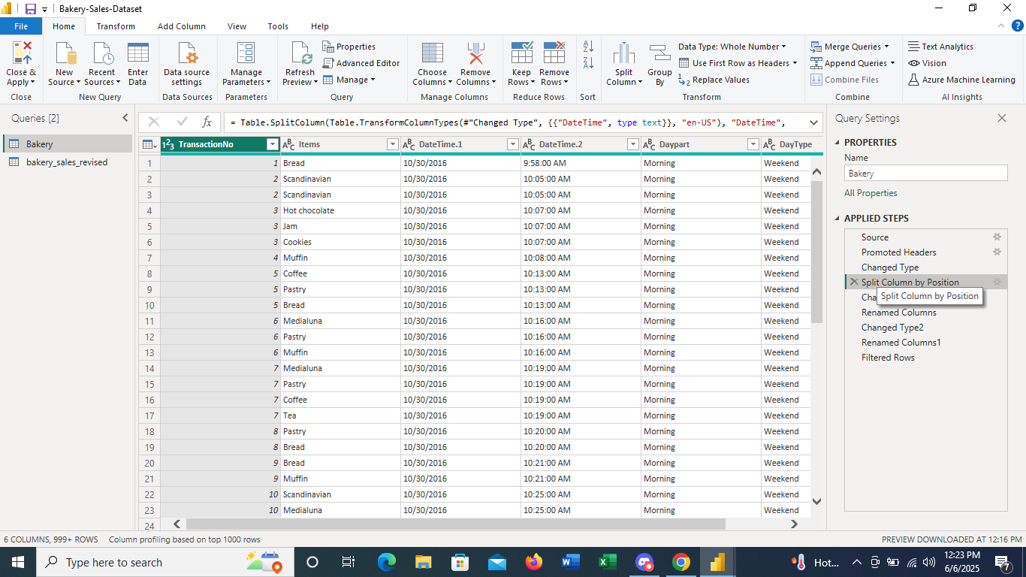

Changed Type 1

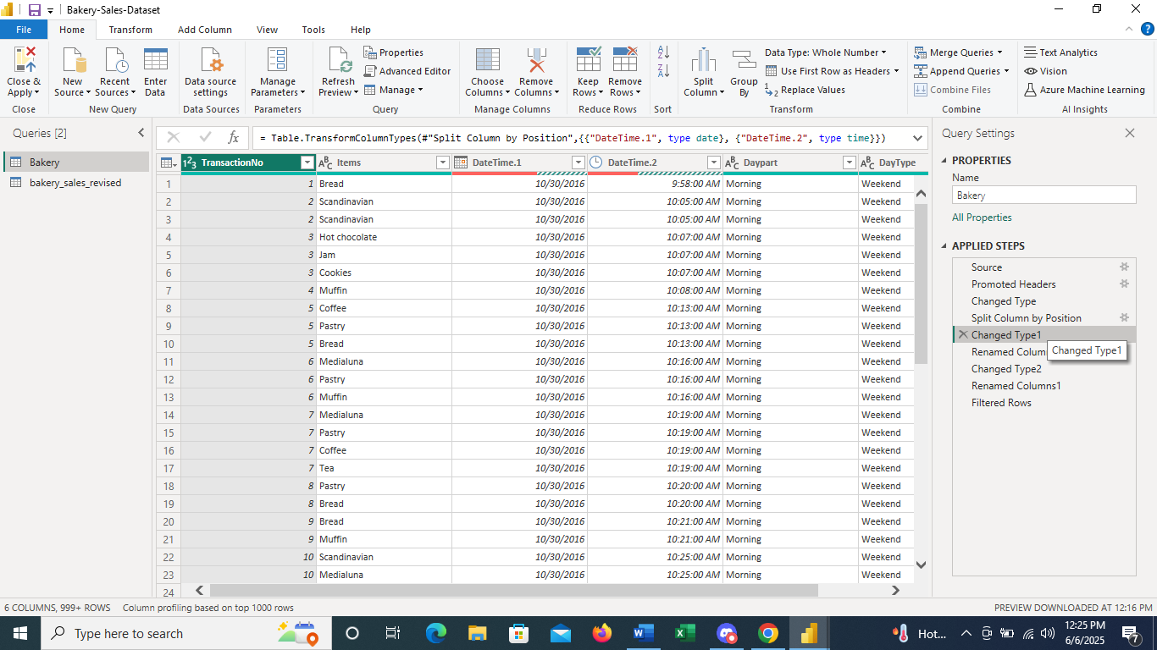

Renamed Column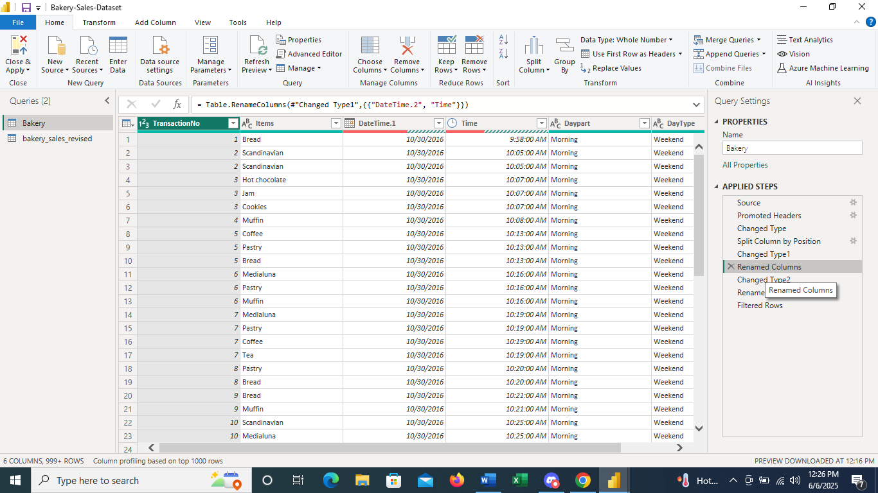

Bakery Sales Revised – Table2

Split column by its position

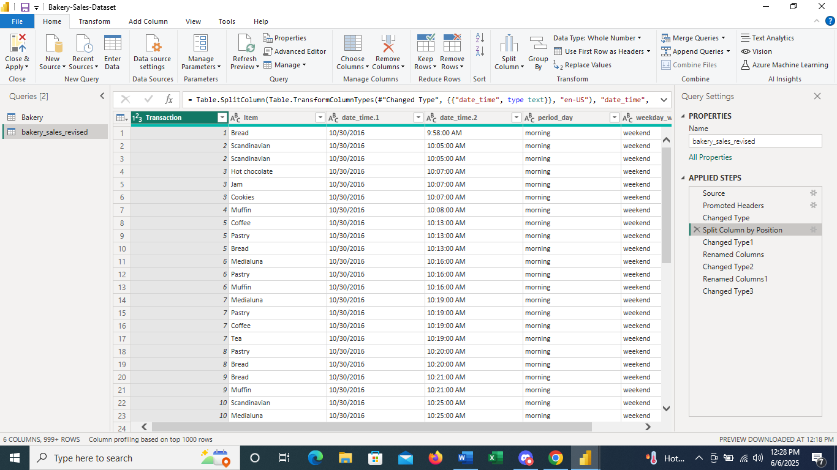

Changed Datatype

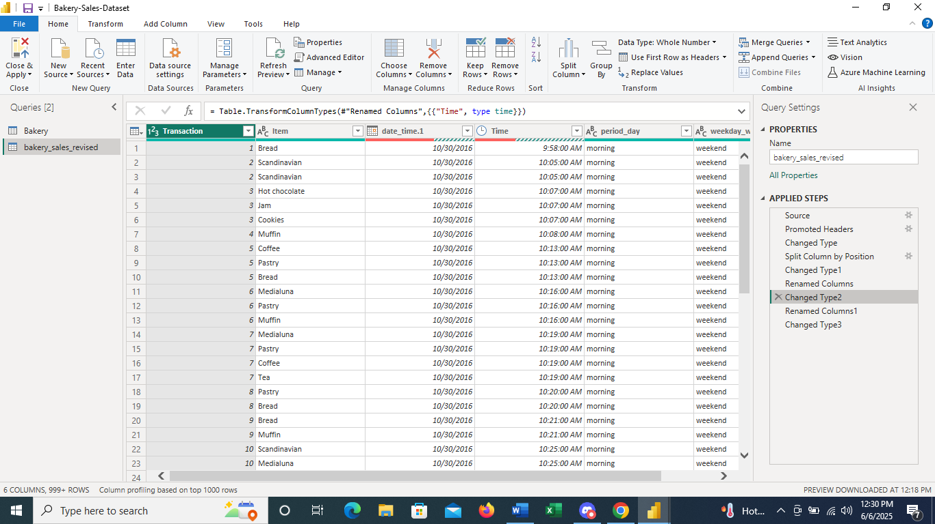

Rename the column name

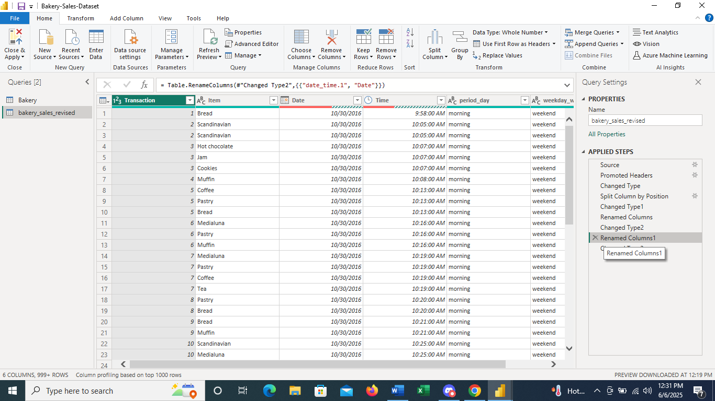

Data Modelling - Primary Key is transaction Id

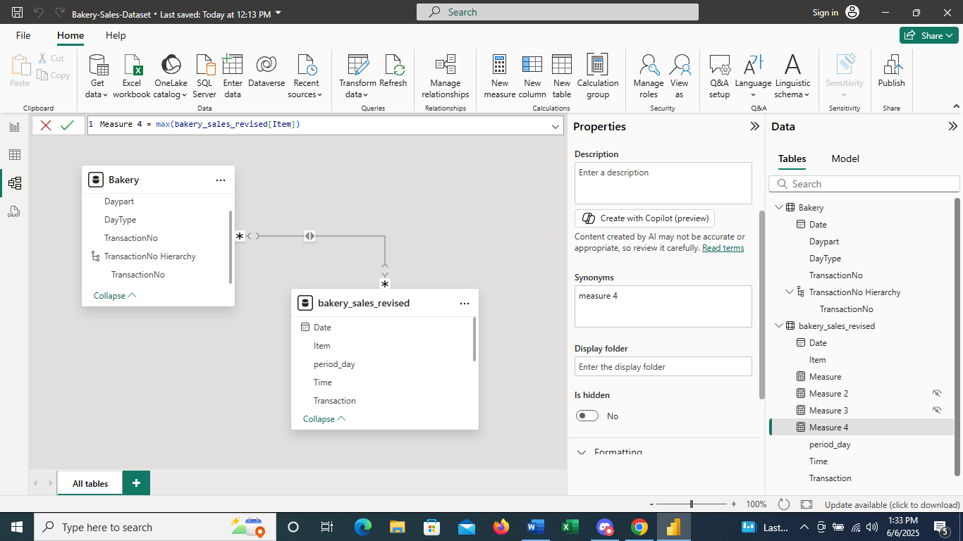

Step 4: After Cleaning load the Data in Power BI window by clicking Close & Apply.

Step 5: Assigned the Primary Key is “Transaction ID”.

Step 6: Created Visualization Using total count of the item, Checking the Delivery using the period like (morning, afternoon, evening).

Step 7 : Found highest order done by weekend or week days.

Step 8: Found most wanted food item by the customer.

Step 9: Finally conclude the Bakery Sales Data Visualization.

Data Visualization for Bakery sales dataset

No of items, week and weekend scenario with period, key influences, Most sell item…..

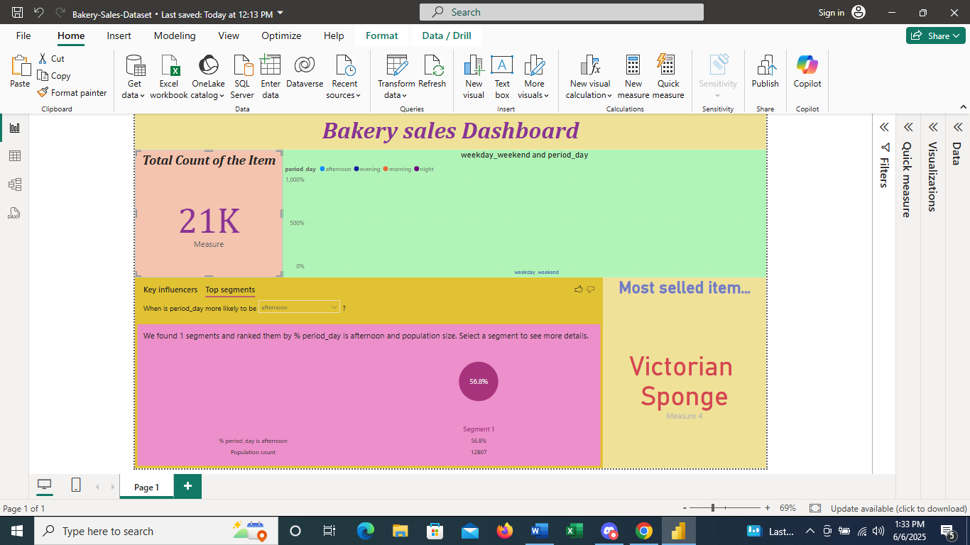

Top segments Data Visualization 